Basic Info abt Dataset: The df contains the result of 100 Advice queries run through the LLm Agent on 03-07-2025, There are a total of 75 uniques stocks comprising of major stocks and some underrated stocks too form various categories to cover the whole market as much as possible.
The basic coulmns in the dataset are : 'Date Time', 'Stock', 'Curr_Price', 'Buy', 'Sell', 'Hold', 'Day1_Pred', 'closest_day1_price', 'actual_day1_close', 'day1_min_error', 'day1_act_error', 'made_profit_could_day_1', 'made_profit_act_day_1', 'Day3_Pred', 'closest_day3_price', 'actual_day3_close', 'day3_min_error', 'day3_act_error', 'made_profit_act_day_3', 'made_profit_could_day_3', 'Day7_Pred', 'closest_day7_price', 'actual_day7_close', 'day7_min_error', 'day7_act_error', 'made_profit_could_day_7', 'made_profit_act_day_7', 'Query', 'Advice', 'profit_1', 'profit_3', 'profit_7', 'Category', 'missed_opportunity_day1', 'missed_opportunity_day3', 'missed_opportunity_day7'

Catogory of stocks and stocks (72):
"Technology": [
"AAPL", "ADBE", "ADP", "AMAT", "AMD", "AMZN", "ASML", "AVGO", "CDNS", "CRM",
"CRWD", "CSGP", "CoStar Group", "DDOG", "DOCU", "GOOGL", "HOOD", "HUBS", "IDXX",
"INTC", "Intuit", "KLAC", "LRCX", "Lam Research", "MCHP", "MDB", "META", "MRVL",
"MSFT", "MU", "Microchip Technology", "NET", "NOW", "NTES", "NVDA", "OKTA", "ORCL",
"PANW", "PINS", "PLTR", "QCOM", "QQQJ", "S", "SAP", "SIRI", "SNAP", "SNOW", "TEAM",
"TSM", "VMW", "WDAY", "ZS"
],
"EV Auto": ["LCID", "LYFT", "NIO", "RIVN", "TSLA"],
"Healthcare": ["BIIB", "IDXX", "ILMN", "ISRG", "REGN", "Seagen", "VRTX"],
"Consumer": [
"ABNB", "AMZN", "CMG", "COST", "DASH", "DIS", "EBAY", "ETSY", "LYFT", "MCD",
"MNST", "PDD", "ROST", "SBUX", "SHOP", "TGT", "UBER", "W", "WBD", "WMT", "eBay"
],
"Semiconductors": [
"AMAT", "KLAC", "LRCX", "Lam Research", "MCHP", "MRVL", "MU",
"Microchip Technology", "TSM"
],
"Media Entertainment": [
"CMCSA", "DIS", "LYV", "NFLX", "PARA", "ROKU", "SIRI", "SPOT", "WBD"
],
"FinTech": ["COIN", "FIS", "FISV", "INTU", "MA", "PYPL", "SQ", "V"],
"Communications": ["CHTR", "CMCSA", "TMUS", "VZ"],
"Real Estate": ["CSGP", "CoStar Group", "Redfin", "Z", "Zillow"],
"Remote Work": ["DOCU", "PLTR", "TEAM", "ZM"],
"Cybersecurity": ["CRWD", "PANW", "ZS"],
"Cloud Data": ["DDOG", "DOCU", "NET", "SNOW"],
"Real Estate": ["CSGP", "CoStar Group", "LYFT", "UBER"]

Most Volatile Stocks: Techonology , Fintech, EV AUTO, Healthcare
Stable Stokcs : Finance, Communications, Cosnumer
📈 1. Prediction Accuracy
- Short-term prediction accuracy:
  - % of times the predicted direction (up/down) was correct.
For Day 1 : 39.10 % times correct
For Day 3 : 37.99 % times correct
For Day 7 : 34.08 % times correct
  - MAE or MAPE between predicted vs. actual (Day1_Pred vs actual_day1_close, etc.).
- MAPE of Day 1: 5.10
- MAPE of Day 3: 6.99
- MAPE of Day 7: 14.92
We can see the longer the forecasting period the error increases and % of correct prediction too.
- Sector Wise Error
Techonology , Fintech, EV AUTO, Healthcare having error rate (15% - 20%)

💰 2. Profitability from Model’s Advice
- Simulated profit/loss based on following LLM/agentic advice (buy/sell/hold) vs. actual outcomes.
- Mean Profit day 1: 47.77777777777778
- Mean Profit day 3: 45.0
- Mean Profit day 7: 41.11111111111111
- Shows the the LLm Agent has provide maximum profit on day 1
🤖 3. Agent Decision Effectiveness
- Measure success rate of agent-generated actions (Buy, Sell, Hold) using:
  - % of profitable buys (Buys = 56)
profit_1 profit_3 profit_7 day1_act_error day3_act_error day7_act_error
0.314815 0.351852 0.351852 3.721260 5.472969 8.587564
  - % of profitable sells (Sells = 47)
profit_1 profit_3 profit_7 day1_act_error day3_act_error day7_act_error
0.909091 0.522727 0.522727 3.083334 4.557476 7.22432
  - % of holds that outperformed avg market drift(Holds = 62)
profit_1 profit_3 profit_7 day1_act_error day3_act_error day7_act_error
0.224 0.448 0.327 7.67 9.66 13.57
LLM has give HOLD as it’s most frequent advice to user
The best action was Sell which lead 91 % times pfrofit on the next daya, Best for Intra day. The worst was performed by Hold action
🔁 4. Could vs. Actual Profit Gap
- Analyze missed opportunity:
  - Difference between made_profit_could_day_n and made_profit_act_day_n
'Day 1': (22.346), 'Day 3': (11.17), 'Day 7': (5.58)}
The llms decision has lead to 22.3% percent missed oppuurtinuity on the next day but for longer period the prediction were acccomadated the stock price and few opportunities were missed.

  - Group missed opportunities by sector
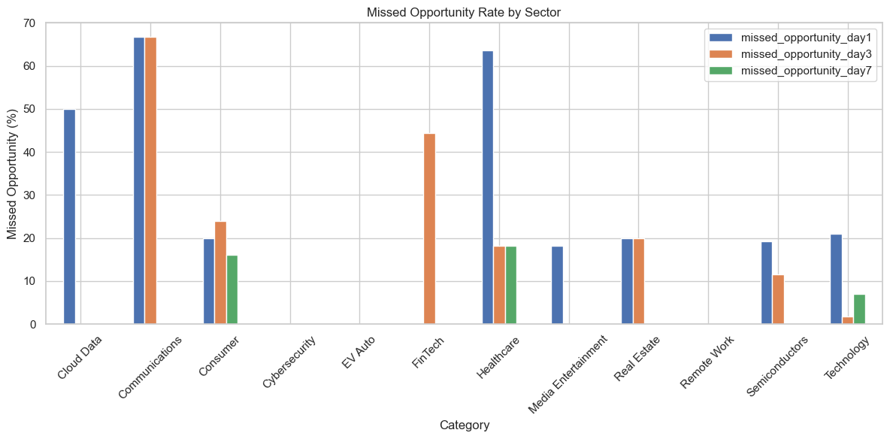
Most missed oppurtunities by secotrs were in Communications, Cloud Data ,Fintech, Healthcare

📊 5. Action Distribution Over Sectors
- How often does the LLM/agent suggest Buy/Sell/Hold in different sectors (Category)? (Intereresting)
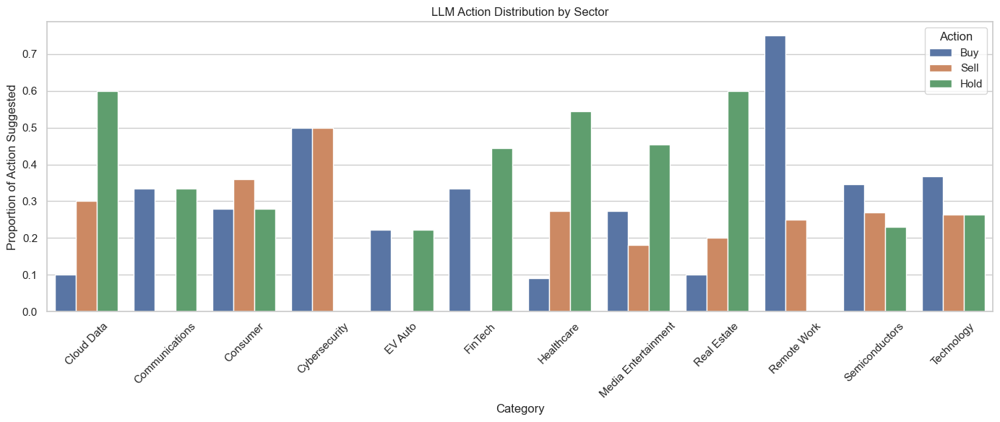
Sectiors with no Sell advice : Communications ,EV Auto ,Fintech,
Sectiors with Hold advice most: Clouddata, Fintech, Healthcare, real estate
Sectors with major Buy advvie: Communicaiton, Cybersecurity , Ev Auto, Remotre Work , Semiconductor, Techonology

📅 7. Multi-Day Forecast Robustness
- Compare Day1, Day3, and Day7 prediction accuracy:
  - Does accuracy degrade as time horizon increases?
Yes,
    - MAPE of Day 1: 5.10
    - MAPE of Day 3: 6.99
    - MAPE of Day 7: 14.92

  - Which stocks are more predictable long-term?
(Communications, Consumer, Media Enterntainment) due to low % of error (< 11%)

📝 Additional Section Ideas for Your Paper
- Architecture: Describe the agentic AI + LLM + market data + news sentiment pipeline.
- Case Studies: Highlight specific stock decisions made by the agent that outperformed (or failed).
- Ethical Considerations: Discuss the potential risks of AI-driven investment advice.

